
TOPIC: INTERNET PROGRAMMING
NAME: JUAKIM NJUGUNA
ADM NO: BSCCS/2024/54733
COURSE: BACHELOR OF SCIENCE IN COMPUTER SCIENCE
UNIT CODE: BIT3208
UNIT NAME: ADVANCED WEB DEVELOPMENT
DEPARTMENT: COMPUTING AND INFORMATICS
ACADEMIC YEAR:3.2
LECTURER: NYORO
SUBMISSION DATE:
PROJECT DETAILS:
PROJECT TITLE:
GITHUB REPOSITORY:
WEBSITE LINK: https://dash.infinityfree.com/accounts/if0_42100248/domains/luxuryproperties.infinityfreeapp.com

Contents
1.0 WEEK 1-3 2

Figure 1 Control panel 3
Figure 2 Operation on local host 3

WEEK 1-3

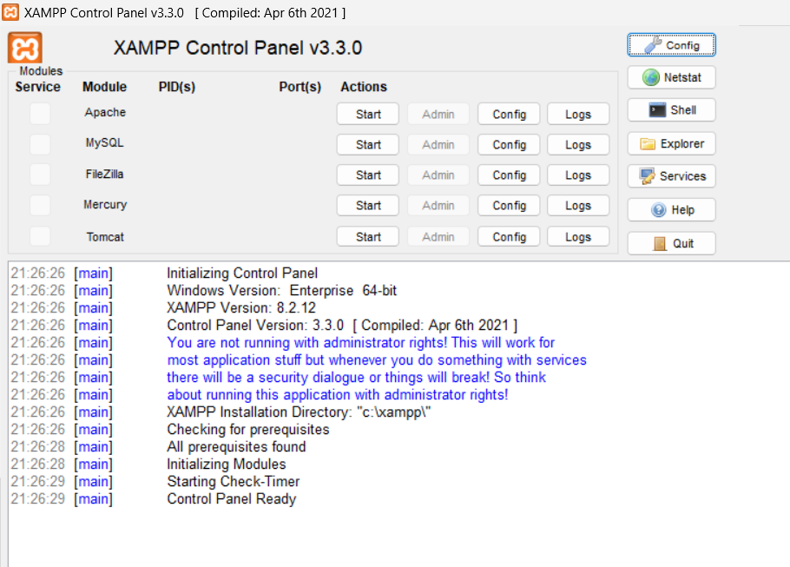
Figure 1 Control panel
The image shows a successfully installed xampp running in the control panel

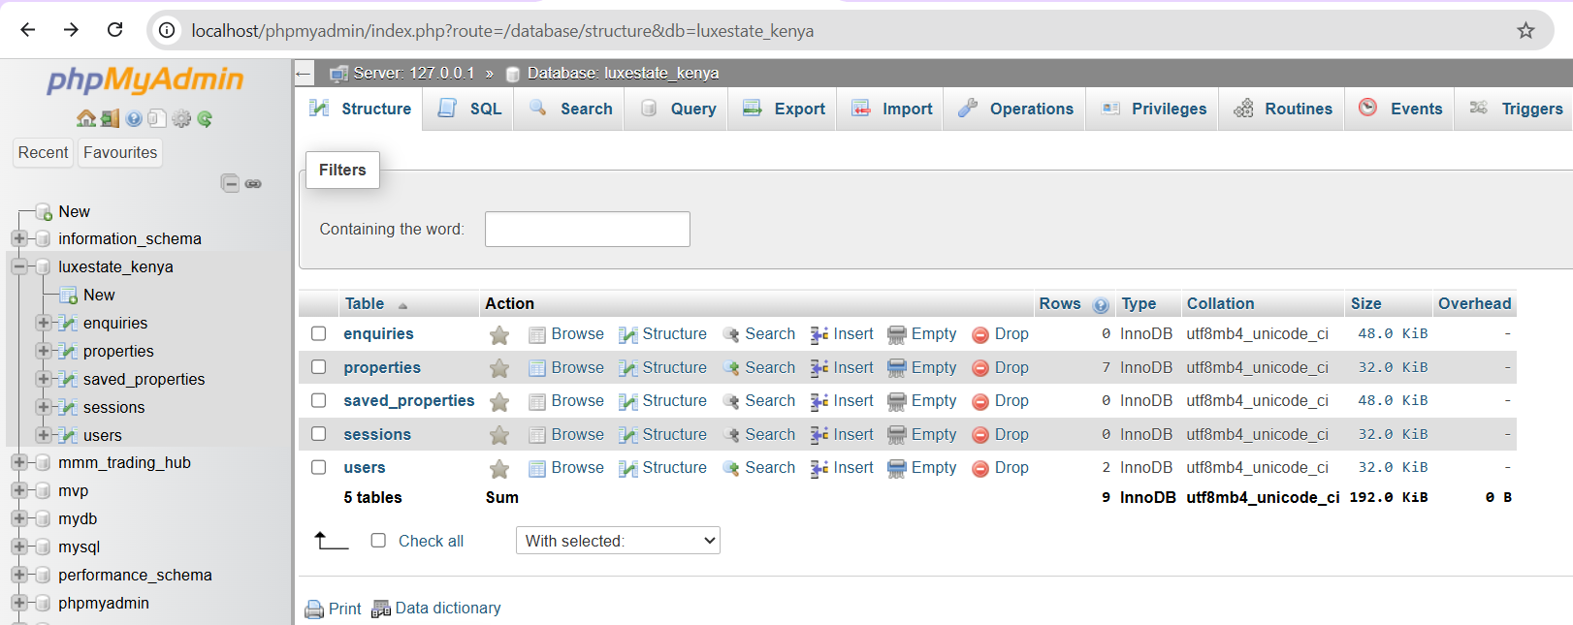
Figure 2 Operation on local host

